**A CRM Application to Manage the Services offered by an Institution**

By -RAHUL SHARMA ( E-mail = rs9433286@gmail.com)

**Create Objects from Spreadsheet**

**1. Create Objects from Spreadsheet**

**a. Create Course Object:**

1. Go to **Object Manager** in Salesforce.
2. Click on **Create Object from Spreadsheet**.
3. Follow the link to download the spreadsheet named **Course**.
4. Upload the spreadsheet file.
5. Map the fields from the spreadsheet to Salesforce fields.
6. Complete the process to create the **Course** object.
7. 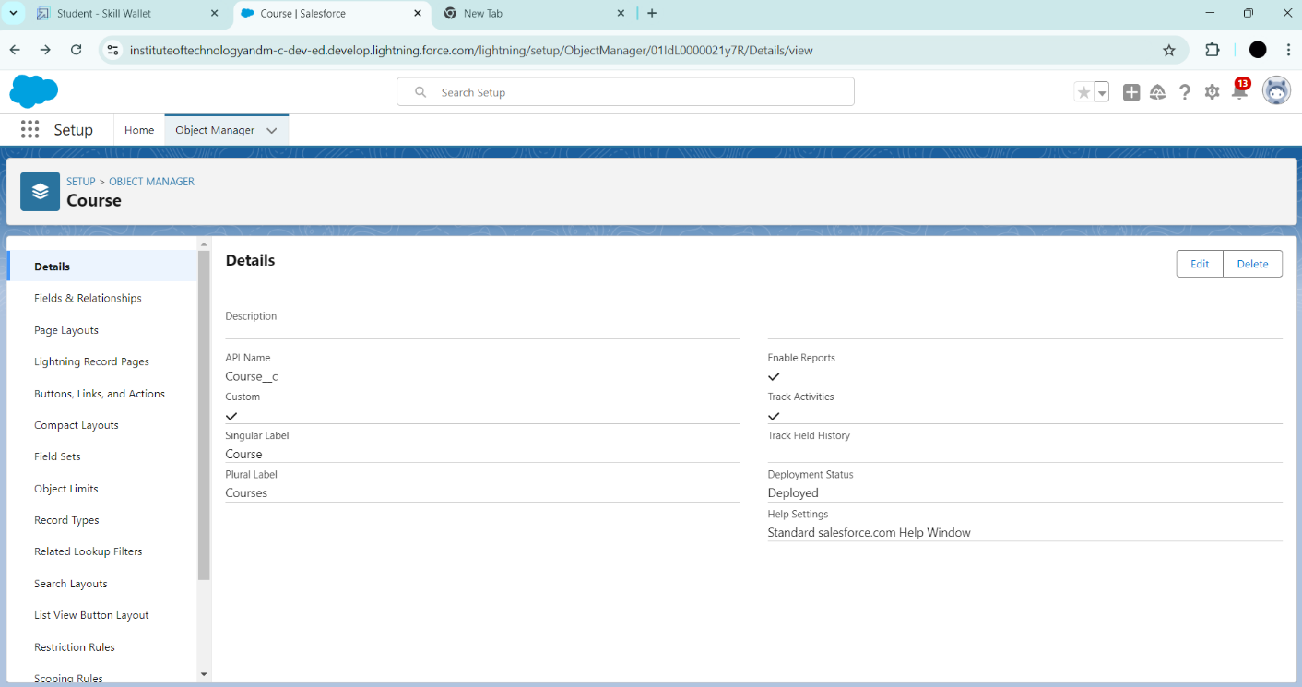

**b. Create Remaining Objects:**

1. Repeat the steps used for creating the Course object.
2. Use the respective spreadsheets to create the following objects:

**Consultant**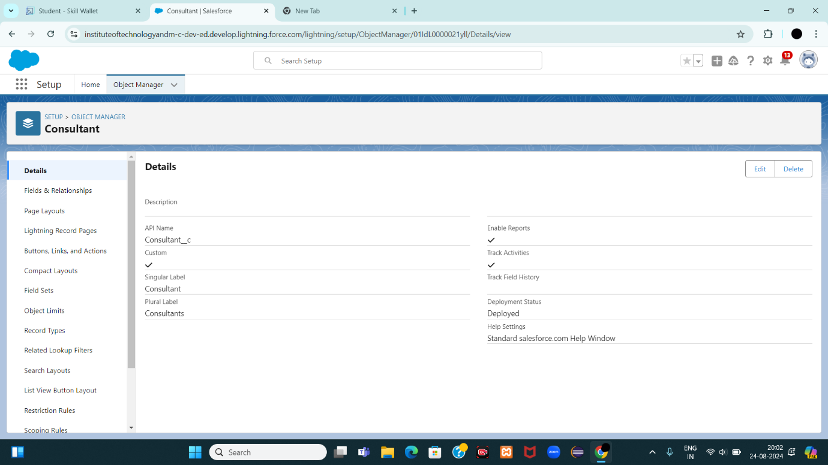

**Student**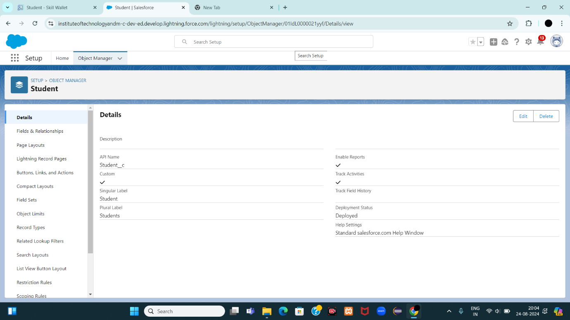

**Appointment**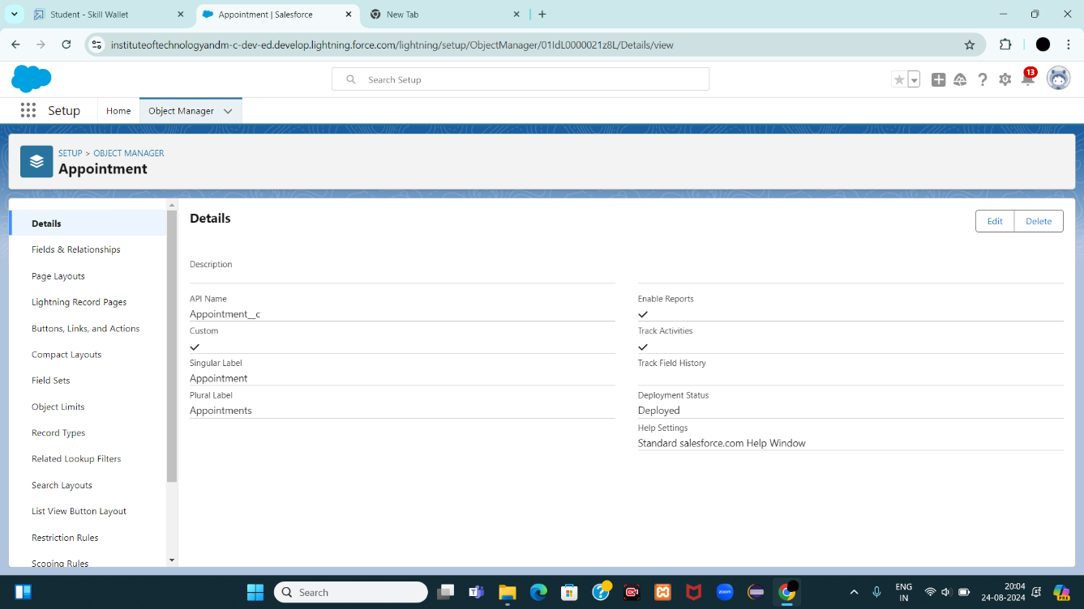

**2. Create Relationships among the Objects**

**a. Lookup Relationship for Appointment:**

1. Go to **Object Manager** and select the **Appointment** object.
2. Create a **Lookup Relationship** between **Appointment** and **Student**.
3. Create another **Lookup Relationship** between **Appointment** and **Consultant**.
4. 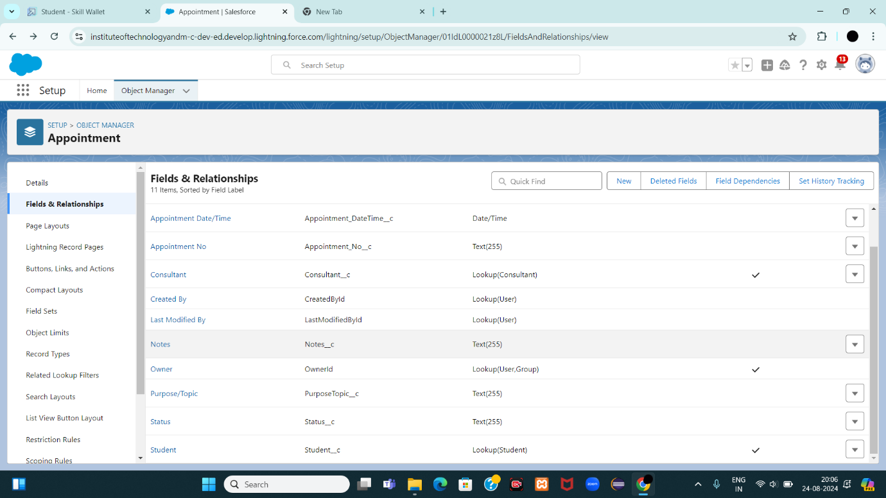

**b. Create Registration Object:**

1. In **Object Manager**, create a new object named **Registration**.
2. 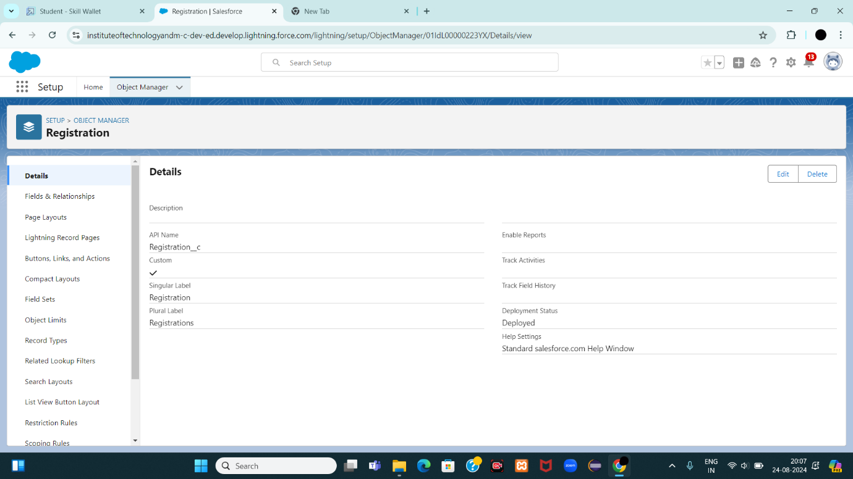
3. Add necessary fields to store information regarding **Student** and **Course** details.
4. Create a **Lookup Relationship** between **Registration** and **Student**.

**c. Additional Lookup Relationship:**

1. Go to the **Object Manager** and select the **Case** object.
2. 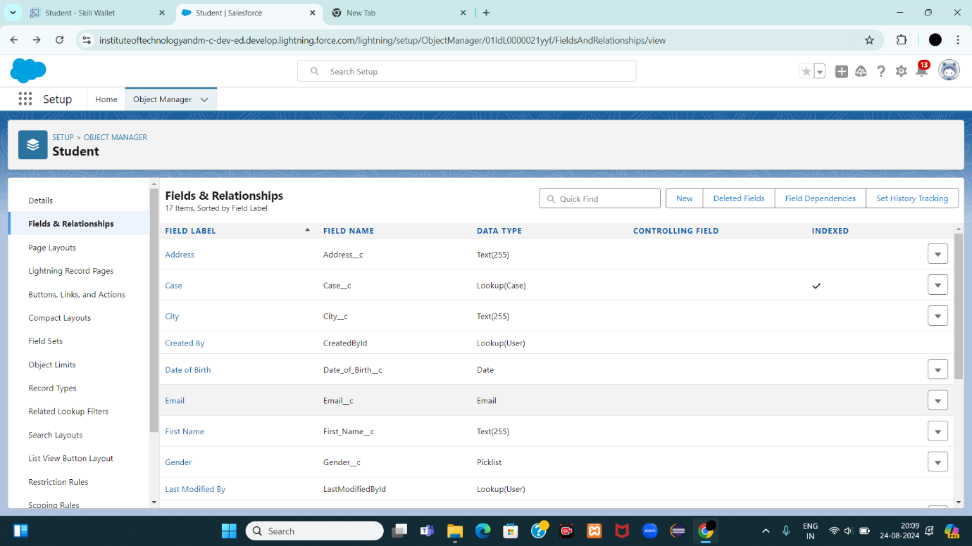Create a **Lookup Relationship** between **Case** and **Student** to store student queries related to immigration or visa application.

**3. Configure the Case Object**

1. In **Object Manager**, select the **Case** object.
2. Edit the **Type** field:
   * Add the values **Immigration** and **Visa Application**.
   * 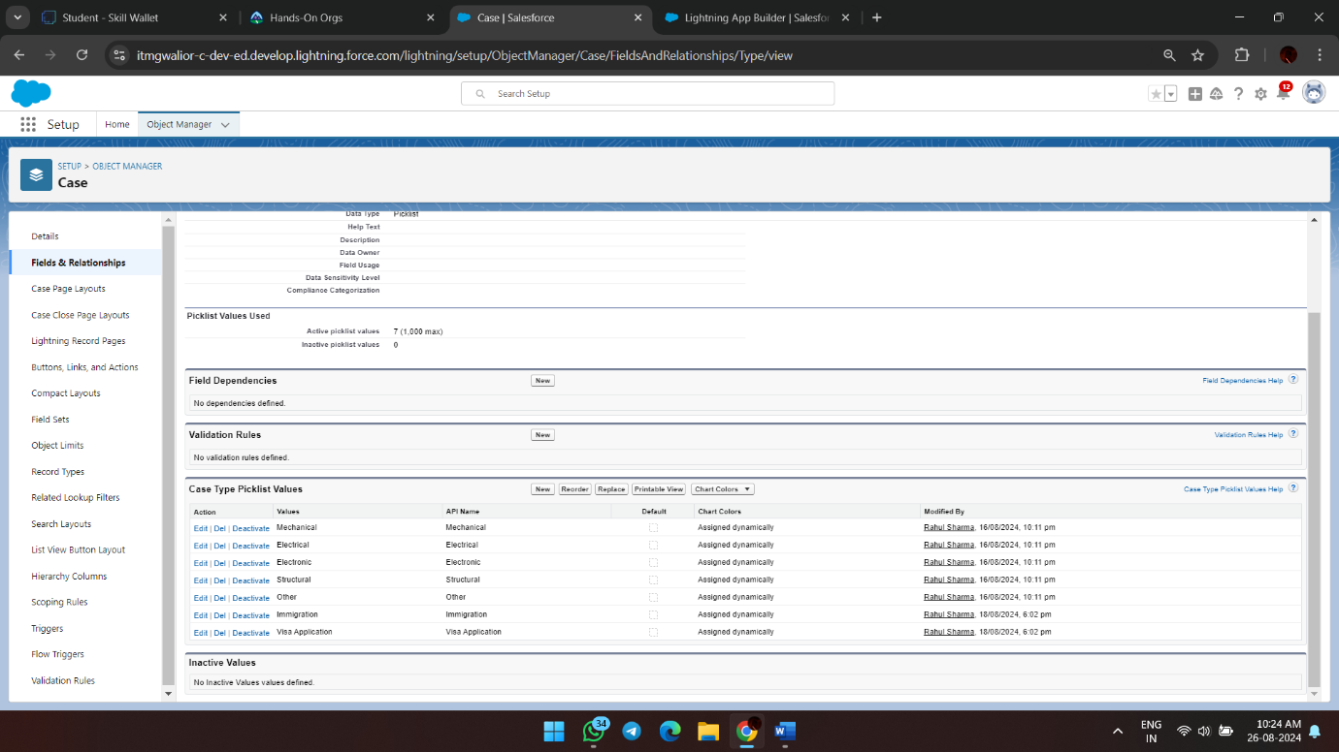
3. Edit the **Status** field:
   * Add the values **Open** and **In-progress**.
   * 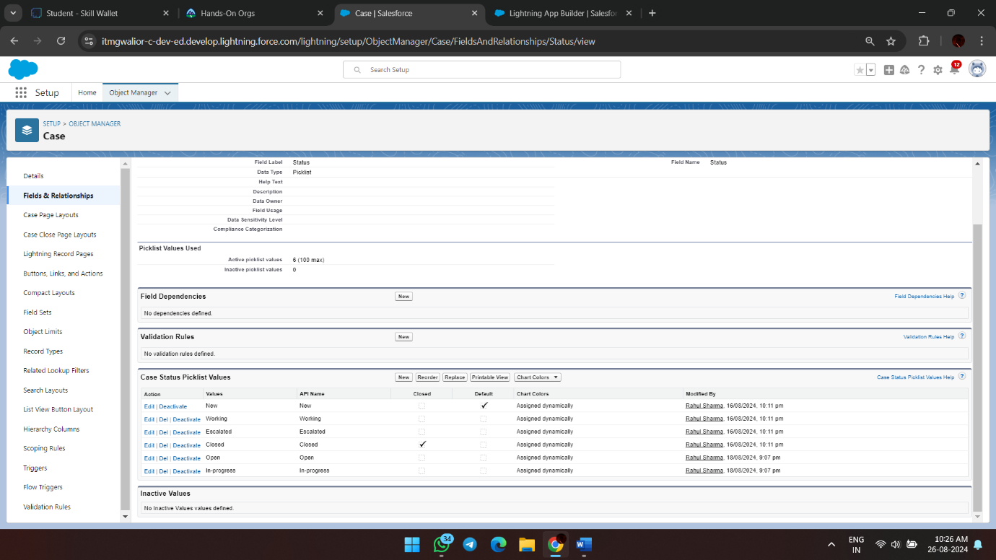

**4. Create a Lightning App**

1. Go to **Setup** in Salesforce.
2. Search for **App Manager** in the Quick Find box.
3. Click on **New Lightning App**.
4. Enter the app name as **EduConsultPro**.
5. Click **Next** through the setup screens.
6. From **Available Items**, select and move **Home**, **Students**, **Courses**, **Consultants**, **Appointments**, **Registrations**, and **Cases** to **Selected Items**.
7. From **Available Profiles**, select **System Administrator** and move it to **Selected Profiles**.
8. Click **Save & Finish**.
9. 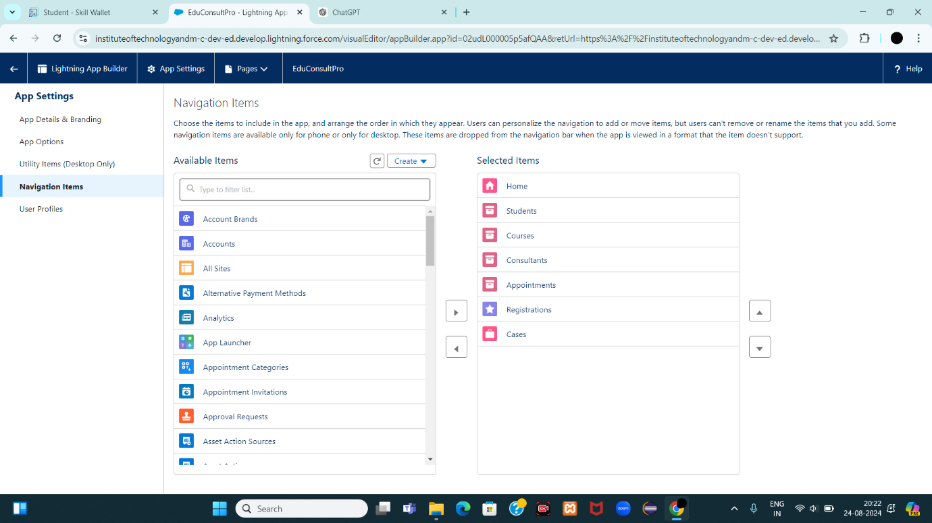

**Create a ScreenFlow for Student Admission Application process.**

**1. Set Up the ScreenFlow**

1. Go to **Setup** in Salesforce.
2. In the Quick Find box, type **Flow Builder** and select **Flow Builder**.
3. Click on **New Flow** and select **Screen Flow**.
4. Click **Create**.

**2. Add Screen Element - Student Info**

1. Drag and drop a **Screen** element onto the canvas.
2. In the **Screen Properties** pane, label it **Student Info**.
3. 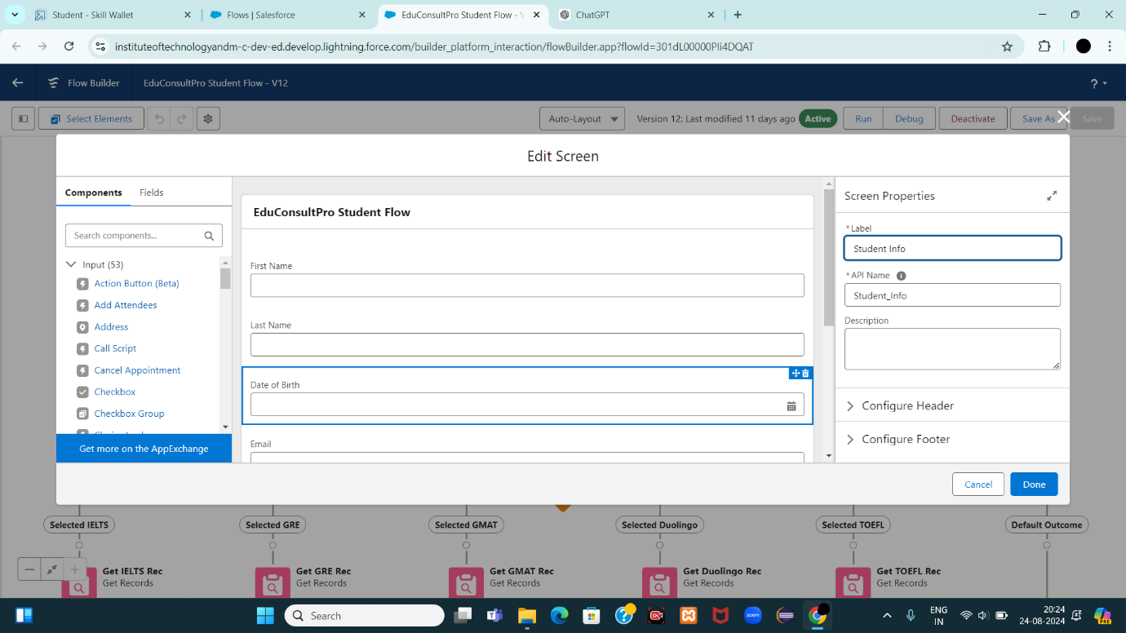
4. Click on **Fields**, then click on the record variable input to create a new resource.
   * **Resource Name**: StudentRecordRes
   * **Type**: **Record**
   * **Object**: **Student**
5. Drag the required fields from the **Student** object onto the screen to collect student information.
6. Click **Done**.

**3. Create Student Record**

1. Drag a **Create Records** element onto the canvas, after the **Student Info** screen.
2. Label it **Create Student Record**.
3. Select **Create One Record** under **How Many Records to Create**.
4. Choose **Use all values from a record** under **How to Set the Record Fields**.
5. For **Record Variable**, select StudentRecordRes (created in the Student Info screen).
6. Click **Done**.
7. 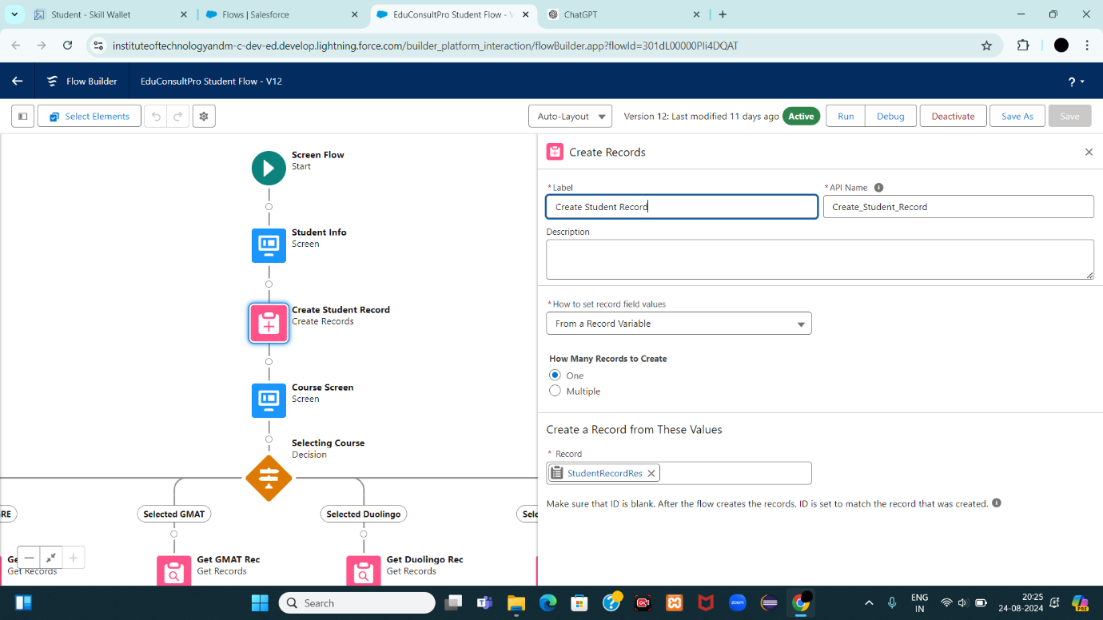

**4. Add Screen Element - Course Selection**

1. Drag another **Screen** element onto the canvas, after the **Create Student Record** element.
2. Label it **Course Screen**.
3. Add a **Picklist** component from the left panel.
   * **Label**: Select Course
   * **Choices**: IELTS, GRE, GMAT, Duolingo, TOEFL (each will create a corresponding variable).
4. Click **Done**.
5. 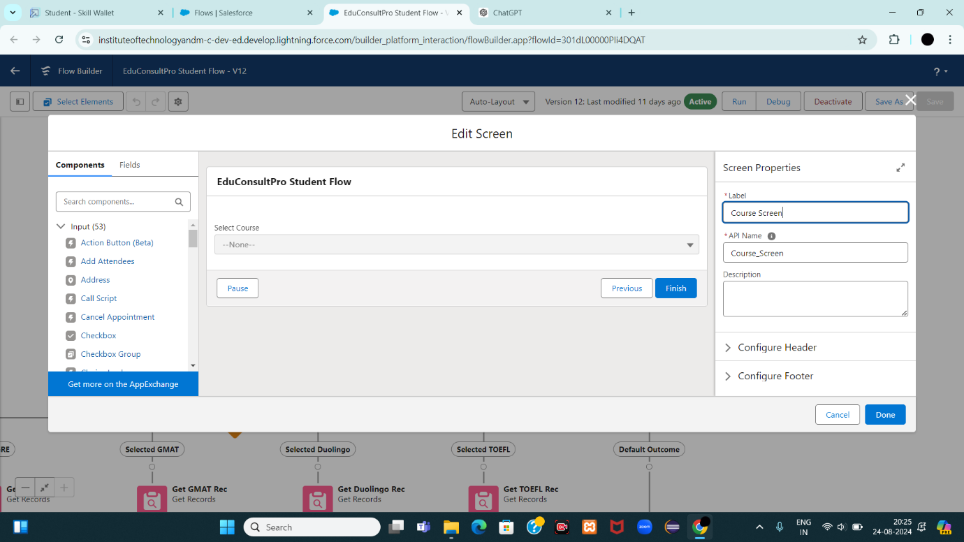

**5. Add Decision Element - Selecting Course**

1. Drag a **Decision** element onto the canvas, after the **Course Screen**.
2. Label it **Selecting Course**.
3. Under **Outcomes**, label the first outcome as **Selected IELTS** and set the condition:
   * **Resource**: Select_Course
   * **Operator**: Equals
   * **Value**: IELTS
4. Repeat the above steps to create outcomes for **GRE**, **GMAT**, **Duolingo**, and **TOEFL**.
5. Click **Done**.
6. 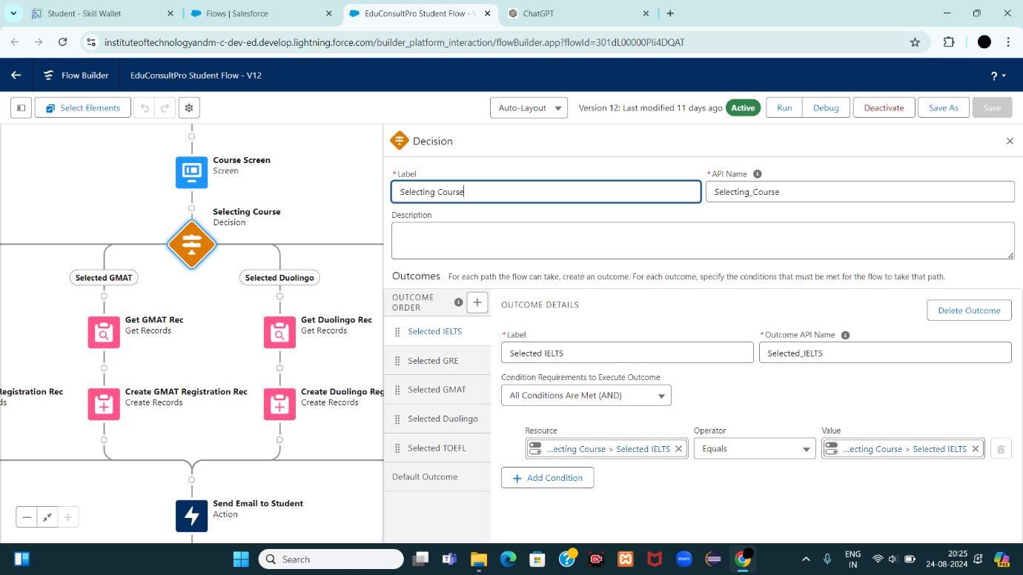

**6. Add Get Record Element - For Each Course**

1. Drag a **Get Records** element onto the canvas, under the **IELTS** path of the Decision element.
2. Label it **Get IELTS Rec**.
3. **Object**: Course
4. **Condition Requirements**: All Conditions are Met (AND)
   * **Field**: Course Name
   * **Operator**: Equals
   * **Value**: Select_Course
5. Click **Done**.
6. 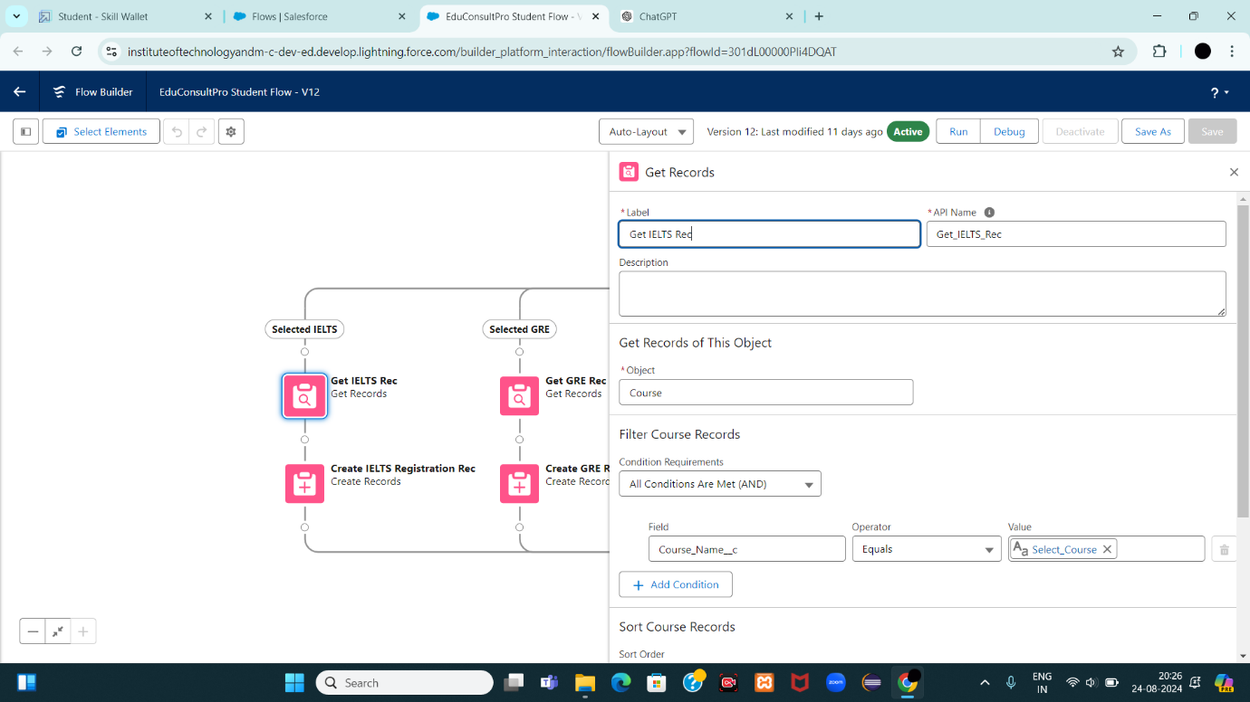
7. Repeat the steps for the other course paths (GRE, GMAT, Duolingo, TOEFL).

**7. Create Registration Record**

1. Drag a **Create Records** element onto the canvas, after each **Get Records** element.
2. Label the element as **Create [Course] Registration Rec** (e.g., **Create IELTS Registration Rec**).
3. Select **Create One Record** under **How Many Records to Create**.
4. Choose **Use separate resources, and literal values** under **How to Set the Record Fields**.
5. **Object**: Registration
6. **Field**: Course_Name__c  
   **Value**: Get_IELTS_Rec.Id
7. **Field**: Student_Name__c**Value**: StudentRecordRes.Id
8. Click **Done**.
9. 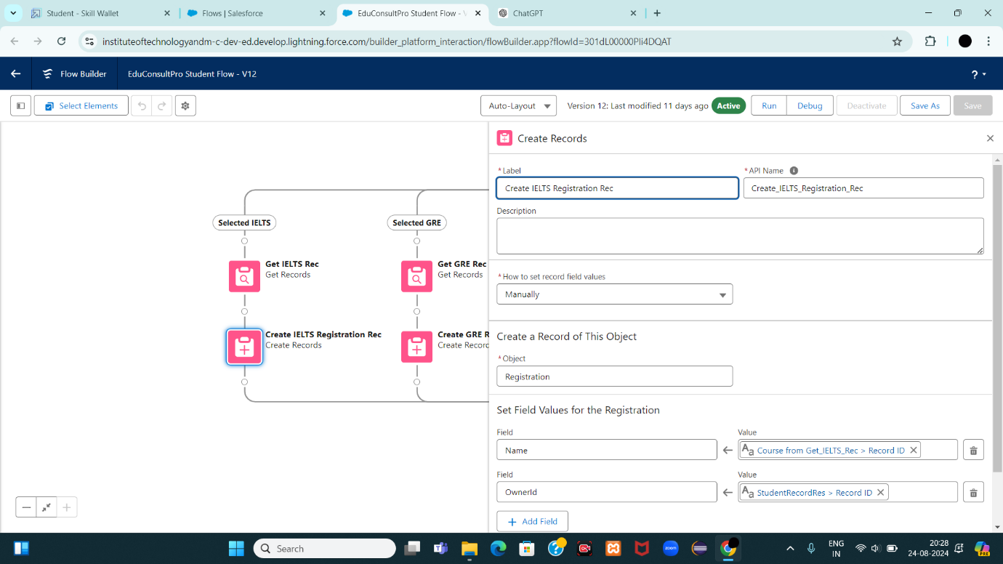
10. Repeat the steps for other courses (GRE, GMAT, Duolingo, TOEFL).

**8. Create Email Text Template Variables**

1. Click the **Toggle Toolbox** on the left corner, then click **New Resource**.
2. Select **Text Template** as the Resource Type.
   * **API Name**: StuRegistrationEmailTextTempBody
   * **View as plain text**: Checked
   * **Body Text**:
   * vbnet
   * Copy code
   * Dear {!StudentRecordRes.Name},  
       
     Congratulations and welcome to EduConsultantPro!  
       
     We are delighted to inform you that your registration on our platform has been successfully completed. You are now part of our esteemed community dedicated to empowering students like you to achieve their educational and immigration aspirations.  
       
     (Other details and instructions...)  
       
     Thank you.
3. Click **Done**.
4. Repeat the steps to create an email text template for the email subject.
   * **API Name**: StuRegistrationEmailTextTempSub
   * **Body Text**: Subject: Welcome to EduConsultantPro - Registration Successful

**9. Add Action Element - Send Email to Student**

1. Drag an **Action** element onto the canvas, after all the Decision paths.
2. Label it **Send Email to Student**.
3. Under **Set Input Values for Selected Action**:
   * **Body**: {!StuRegistrationEmailTextTempBody}
   * **Recipient Address List**: {!StudentRecordRes.Email__c}
   * **Subject**: {!StuRegistrationEmailTextTempSub}
4. Click **Done**.
5. 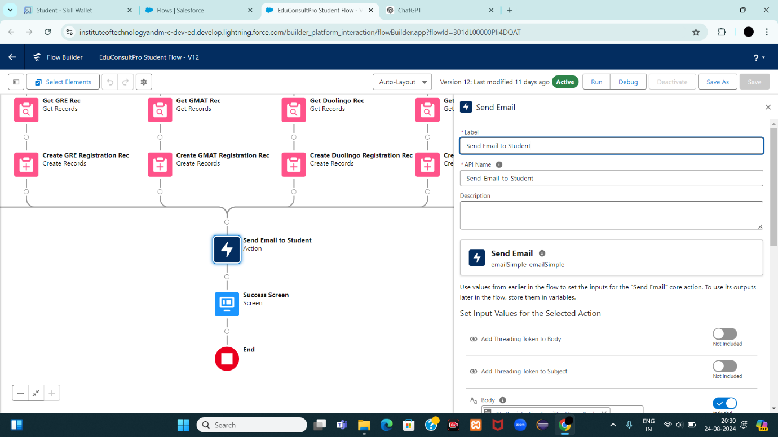

**10. Add Success Screen Element**

1. Drag a **Screen** element onto the canvas, after the **Send Email to Student** action.
2. Label it **Success Screen**.
3. From the left panel, search for the **Display Text** component and drag it to the main panel.
   * **Label**: SuccessMessage
   * **Resource Picker**:
   * vbnet
   * Copy code
   * Dear {!StudentRecordRes.Name},  
       
     Congratulations and welcome to EduConsultantPro!  
       
     We are delighted to inform you that your registration on our platform has been successfully completed. You are now part of our esteemed community dedicated to empowering students like you to achieve their educational and immigration aspirations.  
       
     Your Registration details have been sent through mail kindly check it once.  
       
     Thank you.
4. Click **Done**.
5. 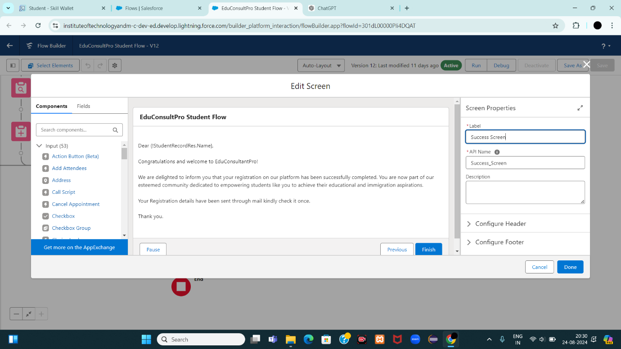

**11. Save and Activate the Flow**

1. Save the flow with the name **EduConsultPro Student Flow**.
2. Click **Activate** to make the flow available for use.

**Create Users**

**1. Create a New User**

1. **Go to Setup:**
   * Log in to Salesforce.
   * Click on the gear icon (Setup) in the top-right corner.
   * In the Quick Find box, type **Users** and select **Users** under **Administration**.
2. **Create New User:**
   * Click on **New User**.
3. **Enter User Information:**
   * **Last Name:** Consultant
   * **Alias:** Auto-filled (can be edited).
   * **Email:** Enter the email address for the new user.
   * **Username:** Enter a unique username (usually the same as the email).
   * **Nickname:** Auto-filled (can be edited).
   * **Role:** Select the appropriate role if needed.
   * **User License:Salesforce Platform**
   * **Profile:Standard Platform User**
   * 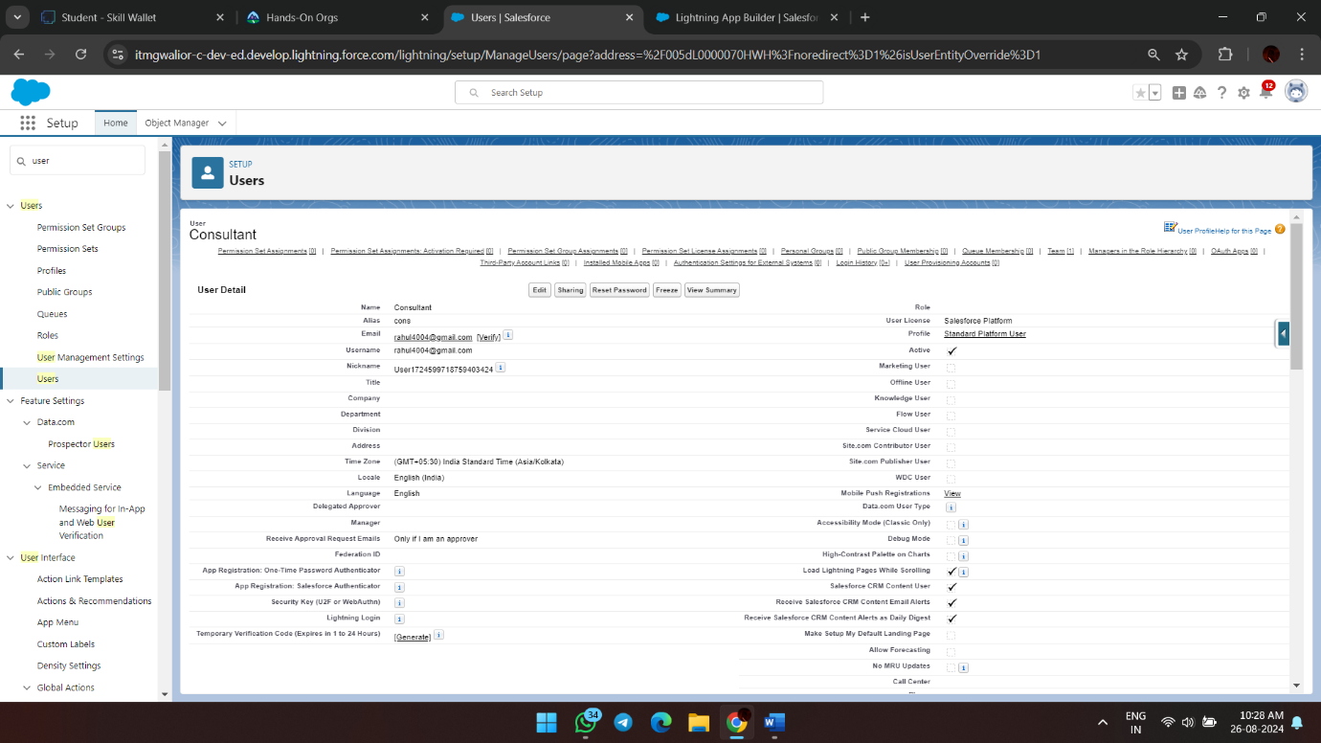
4. **Fill in Other Mandatory Fields:**
   * **Time Zone:** Select the appropriate time zone.
   * **Locale:** Select the appropriate locale.
   * **Email Encoding:** Choose the email encoding.
   * **Language:** Select the preferred language.
5. **Save the User:**
   * Click **Save**.

**2. Configure the User Settings**

1. **Edit User Settings:**
   * Go back to **Setup**.
   * In the Quick Find box, type **Users** and select **Users**.
   * Find the user you just created (Consultant) and click **Edit** next to your name.
2. **Set Manager in Approver Settings:**
   * Scroll down to the **Approver Settings** section at the bottom.
   * In the **Manager** field, select **Consultant** from the dropdown list. 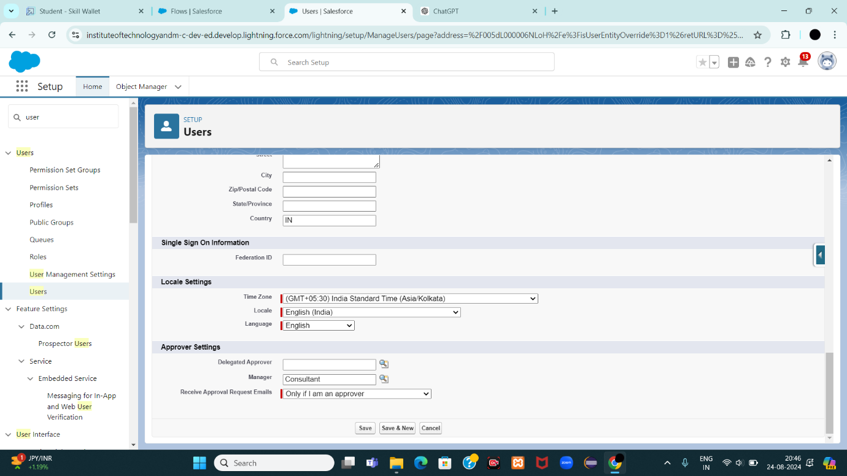
3. **Save Changes:**
   * Click **Save**.

**Create an Approval Process for Property Object**    
**1. Create Email Templates**

**Step 1: Enable Lightning Email Templates**

1. **Go to Setup:**
   * Log in to Salesforce.
   * In the Quick Find box, type **Email Templates**.
   * Select **Lightning Email Templates**.
   * Ensure that the toggle is turned on.

**Step 2: Create a New Email Template Folder**

1. **Open the App Launcher:**
   * Click on the App Launcher (grid icon) in the top-left corner.
   * Search for **Email Templates** and select it.
2. **Create a New Folder:**
   * Click **New Folder**.
   * Name the folder as desired (e.g., "Appointment Templates").
   * Set the access level, if needed, and click **Save**.

**Step 3: Create a Submission Email Template**

1. **Create a New Email Template:**
   * Within the newly created folder, click **New Email Template**.
   * Select the folder you just created.
   * Enter the template details:
     + **Template Name:** Submission Template
     + **Subject:** [Subject you want to use]
     + **HTML Body:**
     + html
     + Copy code
     + Dear {{{Appointment__c.Student_Name__c}}},  
         
       I hope this email finds you well. I am writing to confirm the details of our upcoming appointment scheduled for {{{Appointment__c.Appointment_DateTime__c}}} regarding {{{Appointment__c.PurposeTopic__c}}}.  
         
       Appointment Details:  
       Appointment No : {{{Appointment__c.Name}}},  
       Student Name : {{{Appointment__c.Student_Name__c}}},  
       Consultant Name : {{{Appointment__c.Consultant__c}}},  
       Date & Time : {{{Appointment__c.Appointment_DateTime__c}}},  
       Purpose : {{{Appointment__c.PurposeTopic__c}}}  
         
       I want to assure you that I am looking forward to our meeting and am fully prepared to address any questions or concerns you may have regarding {{{Appointment__c.PurposeTopic__c}}}. Your success and satisfaction are my top priorities, and I am committed to providing you with the guidance and support you need.  
         
       If you have any specific topics or questions you would like to discuss during our appointment, please feel free to share them with me in advance. This will help ensure that our time together is as productive and beneficial as possible.  
         
       If for any reason you need to reschedule or cancel our appointment, please notify me at your earliest convenience so that we can make alternative arrangements.  
         
       Once again, thank you for choosing to work with me on this matter. I am confident that our collaboration will lead to positive outcomes and progress toward your goals.  
         
       If you have any questions or require further information before our scheduled appointment, please don't hesitate to reach out to me.  
         
       Looking forward to our meeting.  
         
       Best regards,  
         
       {{{Recipient.Name}}},  
         
       EduConsultantPro
   * **Save the Template.**

**Step 4: Create Approval and Rejection Email Templates**

1. **Repeat the above steps** to create two more email templates:
   * **Approval Template:** Customize the message for approval.
   * **Rejection Template:** Customize the message for rejection.
   * 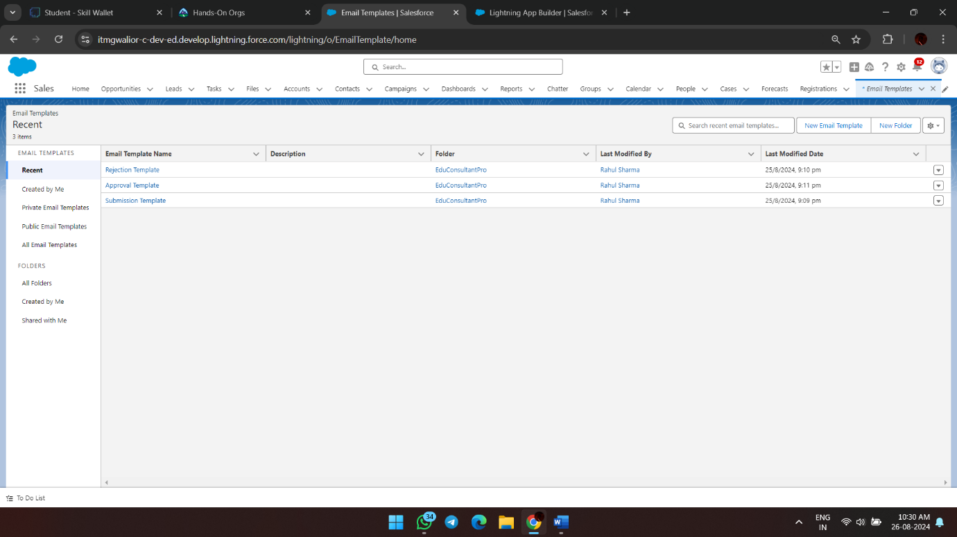

**2. Create an Approval Process**

**Step 1: Start the Approval Process**

1. **Go to Setup:**
   * In the Quick Find box, type **Approval Processes**.
   * Select **Approval Processes**.
2. **Select Object:**
   * Under **Manage Approval Processes For**, select **Appointment**.
3. **Create New Approval Process:**
   * Click **Create New Approval Process**.
   * Select **Use Jump Start Wizard**.

**Step 2: Configure the Approval Process**

1. **Enter Process Details:**
   * **Process Name:** Appointment Approval
   * **Unique Name:** Auto-filled
   * **Entry Criteria:** Set criteria if needed, or leave blank to apply to all records.
2. **Assign Approver:**
   * Under **Select Approver**, select **Manager** for the option **Automatically assign an approver using a standard or custom hierarchy field**.
3. **Set Next Automated Approver:**
   * Click **Next**.
   * **Next Automated Approver Determined By:** Select **Manager**.
4. **Set Record Editability:**
   * From **Record Editability Properties**, select **Administrators OR the currently assigned approver can edit records during the approval process**.
5. **Save the Approval Process:**
   * Click **Save**.

**Step 3: Configure Initial Submission Actions**

1. **View Approval Process Detail Page:**
   * After saving, click **View Approval Process Detail Page**.
2. **Add Field Update:**
   * Under **Initial Submission Actions**, click **Add New** --> **Field Update**.
   * **Field Update Name:** Submitted
   * **Field to Update:** Appointment: Status
   * **Specify New Field Value:** Pending
3. **Add Email Alert:**
   * Under **Initial Submission Actions**, click **Add New** --> **Email Alert**.
   * **Description:** Submission Email Alert
   * **Email Template:** Select **Submission Template**.
   * **Recipient Type:** Select your name or other recipients as needed.

**Step 4: Configure Final Approval and Rejection Actions**

1. **Final Approval Actions:**
   * Add **Field Update** to update the status to **Approved**.
   * Add an **Email Alert** using the Approval Email Template.
2. **Final Rejection Actions:**
   * Add **Field Update** to update the status to **Rejected**.
   * Add an **Email Alert** using the Rejection Email Template.

**Save and Activate the Approval Process**

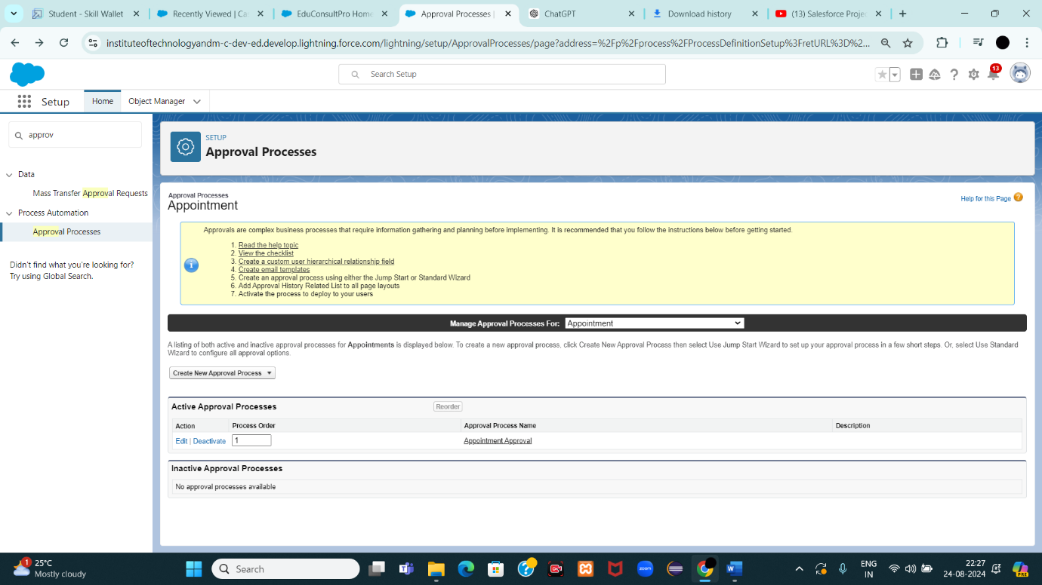

**Create a Record Triggered Flow**

**1. Configure the Start Element**

1. **Go to Setup**:
   * Log in to Salesforce.
   * In the Quick Find box, type **Flows** and select **Flows** under **Process Automation**.
2. **Create a New Flow**:
   * Click on **New Flow**.
   * In the Flow Builder, select **Record-Triggered Flow**.
   * Click **Create**.
3. **Configure the Start Element**:
   * In the **Configure Start** window:
     + For **Object**, select Appointment.
     + For **Trigger the Flow When**, select **A record is created**.
   * The flow will now trigger every time a new Appointment record is created.

**2. Add an Action Element**

1. **Add an Action Element**:
   * After the Start element, drag the **Action** element from the left panel onto the canvas.
   * In the Action field, search for and select **Submit for Approval**.
   * Label the action as **Approval SubFlow**.
2. **Configure the Action Element**:
   * Set the **RecordId** field to {!$Record.Id}. This ensures that the record that triggered the flow (the Appointment record) will be submitted for approval.

**3. Save and Activate the Flow**

1. **Save the Flow**:
   * Click on **Save**.
   * Label the flow as **EduConsultPro Approval Flow**.
   * 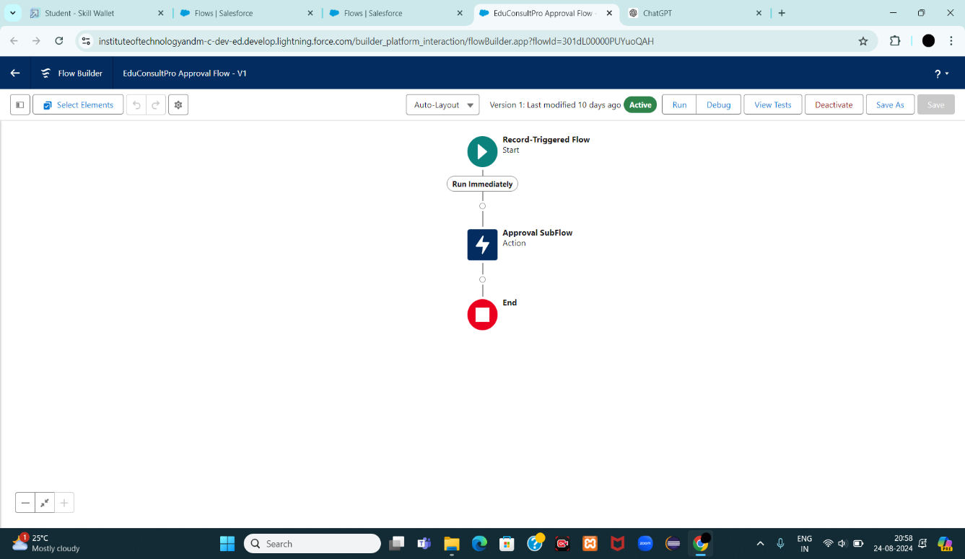
2. **Activate the Flow**:
   * Click on **Activate** to make the flow live.

**Create a ScreenFlow for Existing Student to Book an Appointment**

**1. Create a New Screen Flow**

1. **Go to Setup**:
   * In Salesforce, go to the **Setup** menu.
   * In the Quick Find box, type **Flow** and select **Flow Builder** under **Process Automation**.
2. **Create a New Flow**:
   * Click **New Flow**.
   * Select **Screen Flow**.
   * Click **Create**.

**2. Add a Screen Element to Get Student Info**

1. **Add a Screen Element**:
   * Drag the **Screen** element from the left panel onto the canvas.
   * In the **Screen Properties** pane, set the **Label** to **Get Student Info**.
   * 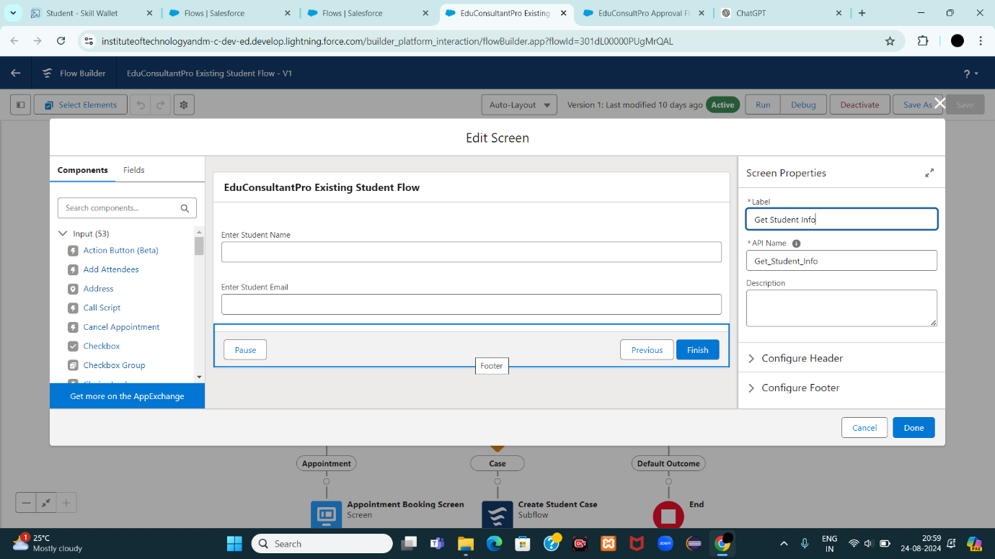
2. **Add Text Components**:
   * From the left side panel, drag two **Text** components onto the screen.
   * Set the labels as follows:
     + **1st Text Component Label**: Enter Student Name
     + **2nd Text Component Label**: Enter Student Email
3. **Click Done** to save this screen.

**3. Add a GET Record Element to Fetch Student Record**

1. **Add a GET Record Element**:
   * After the Screen element, drag the **Get Records** element onto the canvas.
   * Label it as **Get Rec**.
2. **Configure the GET Record Element**:
   * **Object**: Select **Student**.
   * **Condition Requirements**: Set to **All Conditions Are Met (AND)**.
     + **Field**: Student Name  
       **Operator**: Equals  
       **Value**: !{Enter_Student_Name}
     + **Field**: Email__c  
       **Operator**: Equals  
       **Value**: !{Enter_Student_Email}
3. **Click Done** to save this element. 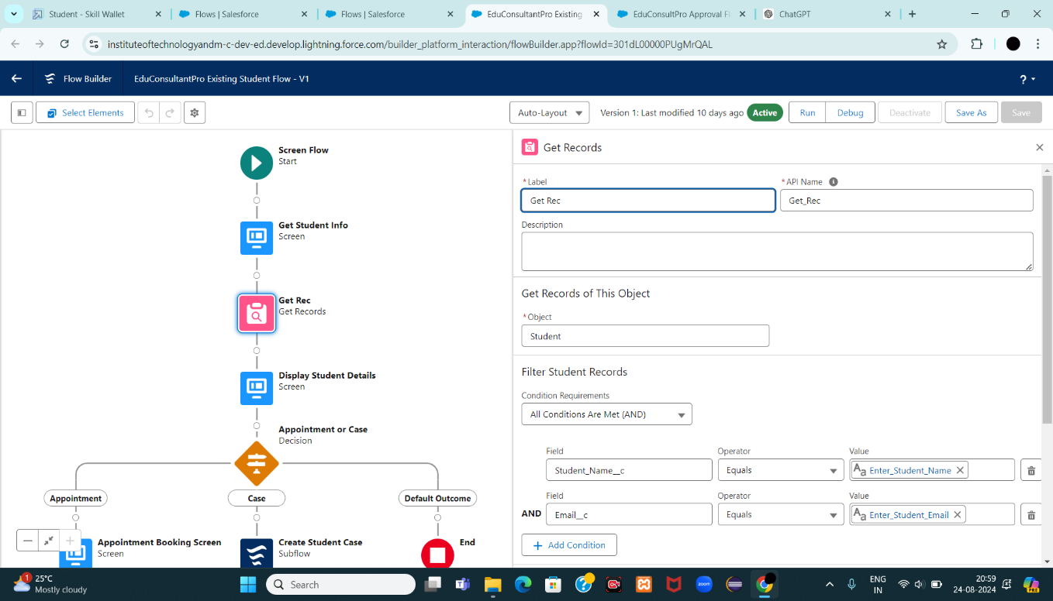

**4. Add a Decision Element to Choose Between Appointment or Case**

1. **Add a Decision Element**:
   * Drag the **Decision** element onto the canvas after the Get Record element.
   * Label it as **Appointment or Case**.
2. **Configure the Decision Element**:
   * **Outcome Label**: Appointment  
     **Resource**: !{How_may_I_Help_you}  
     **Operator**: Equals  
     **Value**: !{Book_an_Appointment}
   * Click the **+** icon to add another outcome.
     + **Outcome Label**: Case  
       **Resource**: !{How_may_I_Help_you}  
       **Operator**: Equals  
       **Value**: !{Create_a_Case}
3. **Click Done** to save this element.
4. 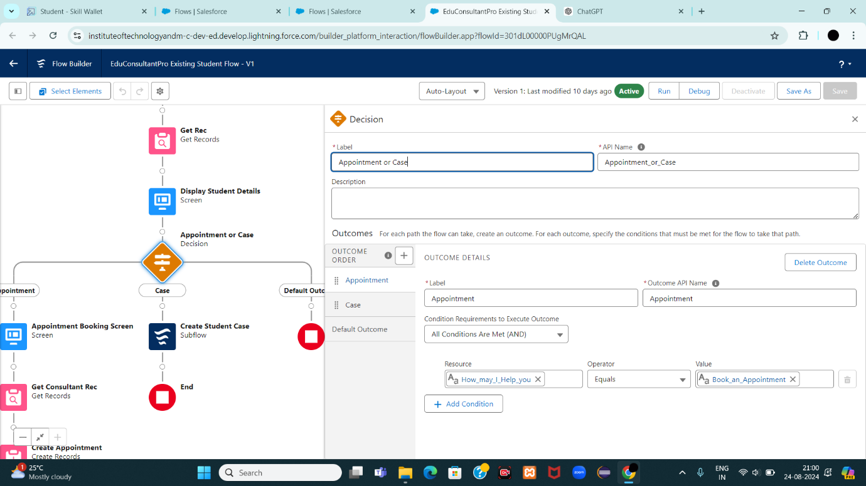

**5. Add a Screen Element for Appointment Booking**

1. **Add a Screen Element**:
   * After the Decision element, on the **Appointment** path, add another **Screen** element.
   * Label it as **Appointment Booking Screen**.
2. **Create a New Resource**:
   * Click on **Fields** in the screen editor.
   * Select the record variable input and create a new resource called **AppointmentRecordRes** to display all fields in the **Appointment** object.
3. **Add Fields to the Screen**:
   * Drag all necessary fields (e.g., Date, Time, Purpose, etc.) from the **Appointment** object to the screen to collect student information.
4. **Click Done** to save this screen. 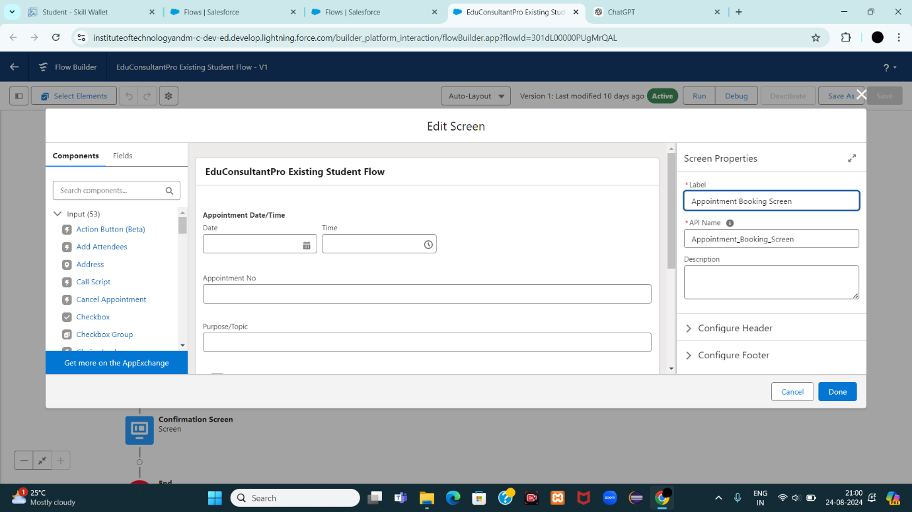

**6. Add a GET Record Element to Fetch Consultant Record**

1. **Add a GET Record Element**:
   * After the Appointment Booking Screen, drag another **Get Records** element onto the canvas.
   * Label it as **Get Consultant Rec**.
2. **Configure the GET Record Element**:
   * **Object**: Select **Consultant**.
   * **Condition Requirements**: Set to **All Conditions Are Met (AND)**.
     + **Field**: Name  
       **Operator**: Equals  
       **Value**: !{AppointmentRecordRes.Consultant_Name__c}
3. **Click Done** to save this element.
4. 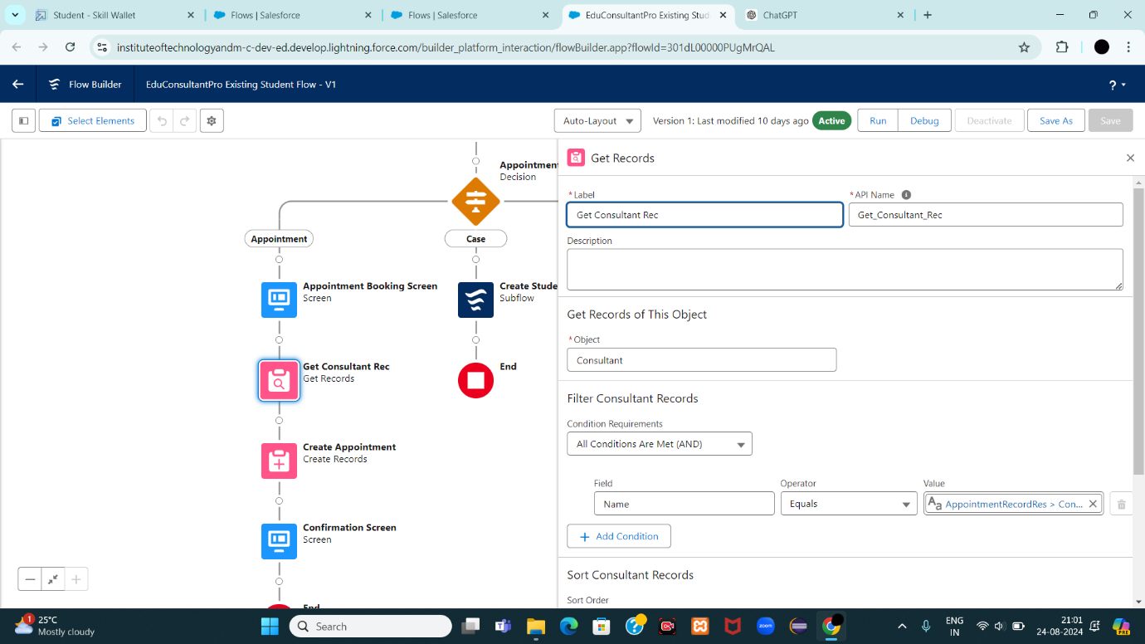

**7. Create the Appointment Record using Create Records Element**

1. **Add a Create Records Element**:
   * After the Get Consultant Rec element, drag the **Create Records** element onto the canvas.
   * Label it as **Create Appointment**.
2. **Configure the Create Records Element**:
   * **How many records to create?**: Select **One**.
   * **How to Set the Record Fields?**: Select **Use separate resources, and literal values**.
   * **Object**: Select **Appointment**.
3. **Set the Field Values**:
   * **Field**: Appointment_DateTime__c  
     **Value**: !{AppointmentRecordRes.Appointment_DateTime__c}
   * **Field**: Consultant__c  
     **Value**: !{Get_Consultant_Rec.Id}
   * **Field**: Notes__c  
     **Value**: !{AppointmentRecordRes.Notes__c}
   * **Field**: PurposeTopic__c  
     **Value**: !{AppointmentRecordRes.PurposeTopic__c}
   * **Field**: Student_Name__c  
     **Value**: !{Get_Rec.Id}
4. **Click Done** to save this element.
5. 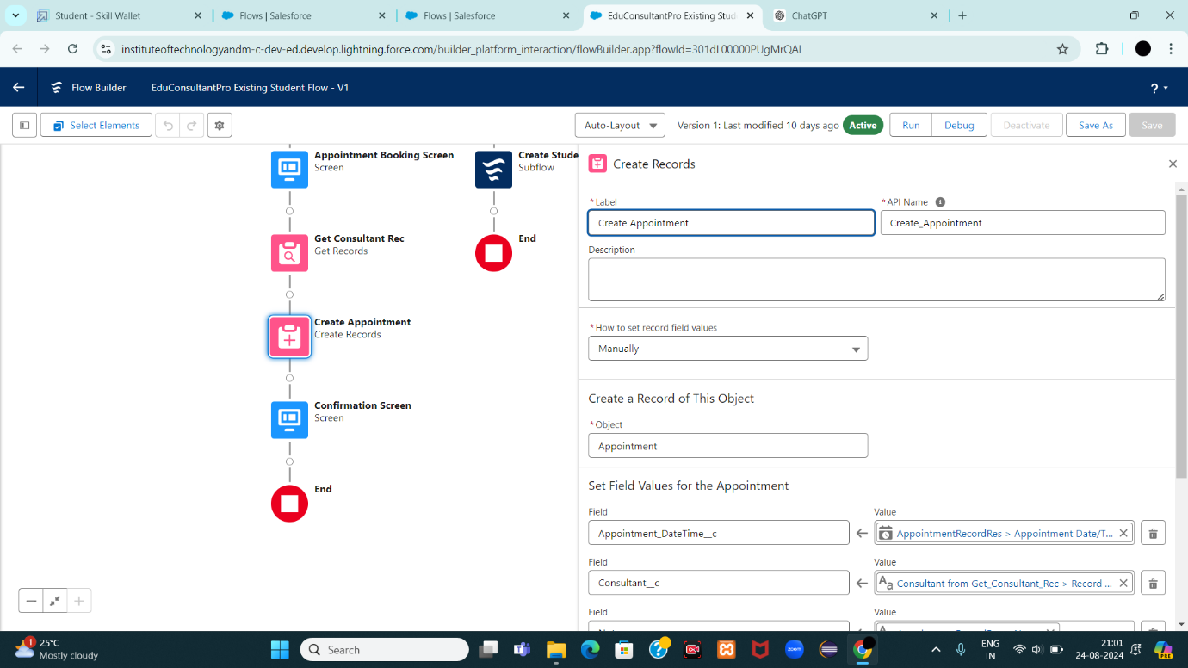

**8. Add a Screen Element for Confirmation**

1. **Add a Screen Element**:
   * After the Create Appointment element, add another **Screen** element.
   * Label it as **Confirmation Screen**.
2. **Add Display Text**:
   * From the left panel, drag the **Display Text** component onto the screen.
   * Label it as **Appointment_Confirmation**.
3. **Configure the Display Text**:
   * In the Resource picker box, paste the following:
   * yaml
   * Copy code
   * Consultant Name: {!Get_Consultant_Rec.Name}  
     Date & Time: {!AppointmentRecordRes.Appointment_DateTime__c}  
     Notes: {!AppointmentRecordRes.Notes__c}
4. **Click Done** to save this element.
5. 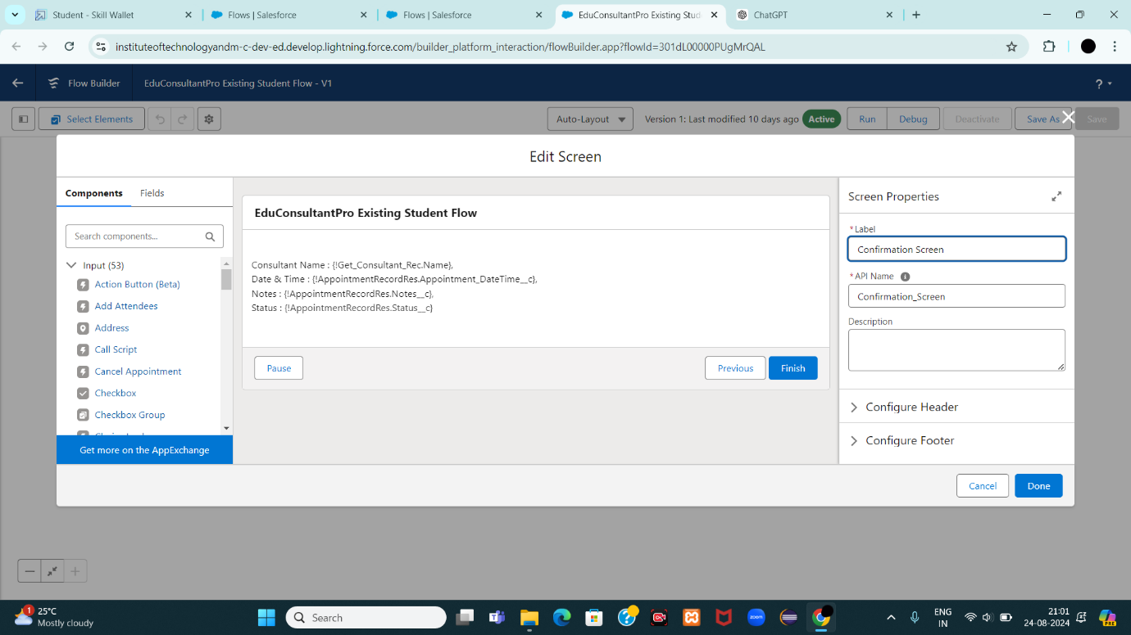

**9. Add a SubFlow Element for Creating a Case**

1. **Add a SubFlow Element**:
   * After the Decision element, on the **Case** path, add a **SubFlow** element.
   * Search for and select **Create a Case**.
   * Label it as **Create Student Case**.
2. **Click Done** to save this element.

**10. Save and Activate the Flow**

1. **Save the Flow**:
   * Label it as **EduConsultantPro Existing Student Flow**.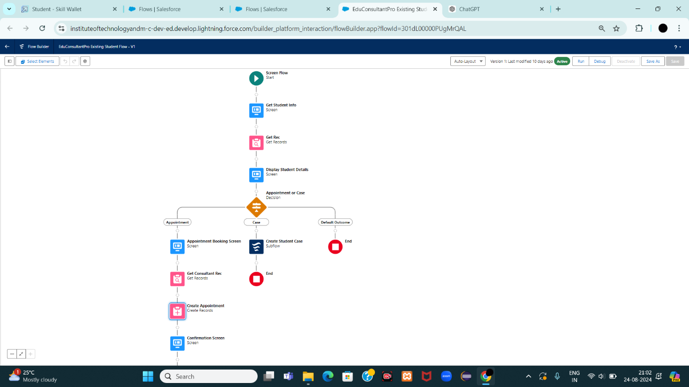
2. **Activate the Flow**:
   * Click on **Activate** to make it live.

**Create a ScreenFlow to Combine all the flows at one place**

**1. Add a Screen Element: Welcome Screen**

1. **Create a New ScreenFlow**:
   * Go to Setup, type **Flow Builder** in the Quick Find box, and select **Flow Builder**.
   * Click on **New Flow** and select **Screen Flow**.
2. **Add a Screen Element**:
   * Drag a **Screen** element onto the canvas.
   * In the **Screen Properties** pane, label it as **Welcome Screen**.
3. **Add Display Text Component**:
   * From the left side panel, search for **Display Text** and drag it to the main panel.
   * Label the component as **SuccessMessage**.
   * In the **Resource Picker** box, paste the following text:
4. vbnet
5. Copy code
6. Welcome to EduConsultantPro  
     
   Your premier destination for education and immigration solutions!  
     
   At EduConsultantPro, we understand that embarking on educational or immigration journeys can be both exhilarating and daunting. That's why we're here to guide you every step of the way with expertise, dedication, and personalized support.  
     
   Whether you're seeking to pursue your academic dreams abroad, navigate the complexities of immigration processes, or enhance your professional skills through international opportunities, EduConsultantPro is your trusted partner.  
     
   Our team of seasoned consultants is committed to understanding your unique aspirations and crafting tailored strategies to help you achieve your goals efficiently and effectively. From selecting the right educational institution to navigating visa procedures, our comprehensive services cover all aspects of your journey.  
     
   At EduConsultantPro, we believe in fostering inclusive communities and unlocking the full potential of every individual. With our unwavering commitment to excellence and integrity, we strive to make your experience with us seamless and rewarding.  
     
   Welcome to EduConsultantPro – where your aspirations meet our expertise, and together, we pave the path to success. Let's embark on this transformative journey together!
7. **Click Done** to save the screen element. 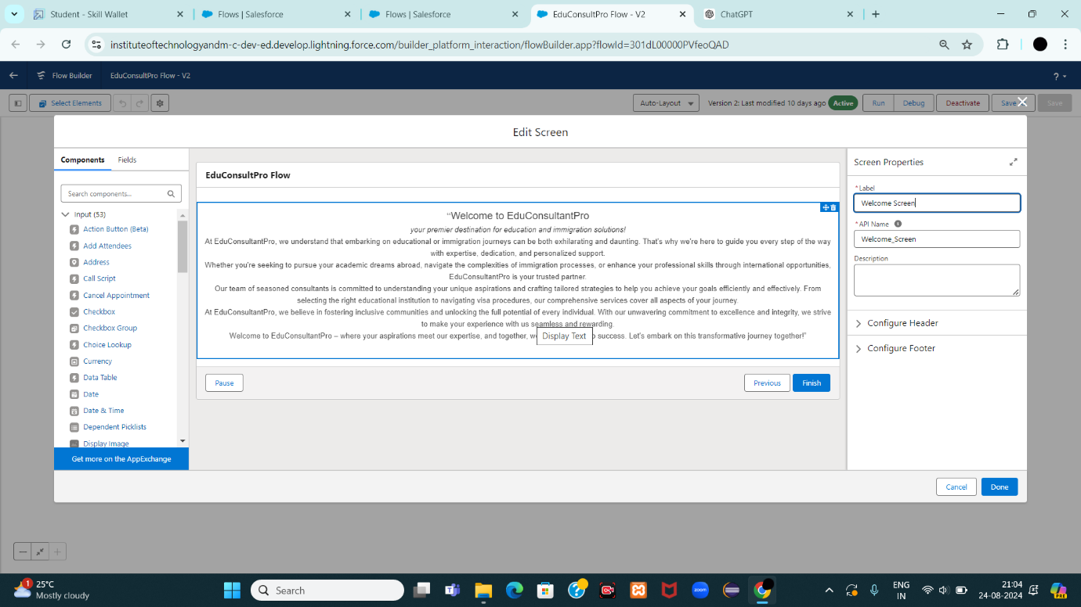

**2. Add a Screen Element: Existing or New Student Confirmation Screen**

1. **Add Another Screen Element**:
   * Drag a **Screen** element after the **Welcome Screen** element.
   * Label it as **Existing or New Student Confirmation Screen**.
2. **Add Radio Button Component**:
   * From the left side panel, add a **Radio Button** component.
   * Set the **Label** to **Are you an Existing Student**.
3. **Create Choices**:
   * Click on **Add Choice** and type "Yes" in the input field, then click **Create Yes choice**.
   * Repeat the above step to create a "No" choice resource.
4. **Click Done** to save the screen element.
5. 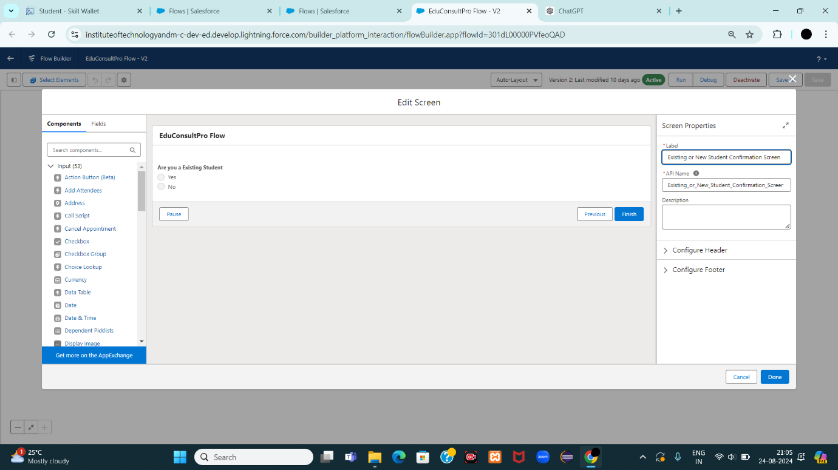

**3. Add a Decision Element**

1. **Add a Decision Element**:
   * Drag a **Decision** element after the **Existing or New Student Confirmation Screen** element.
   * Label it as **Decision 1**.
2. **Create Outcomes**:
   * Under **Outcome Label**, enter **If Existing Student**.
   * Set the **Condition** as follows:
     + **Resource**: {!Are_you_a_Existing_Student}
     + **Operator**: Equals
     + **Value**: {!Yes}
   * Click the "+" icon and repeat the steps to create an outcome for "No".
   * 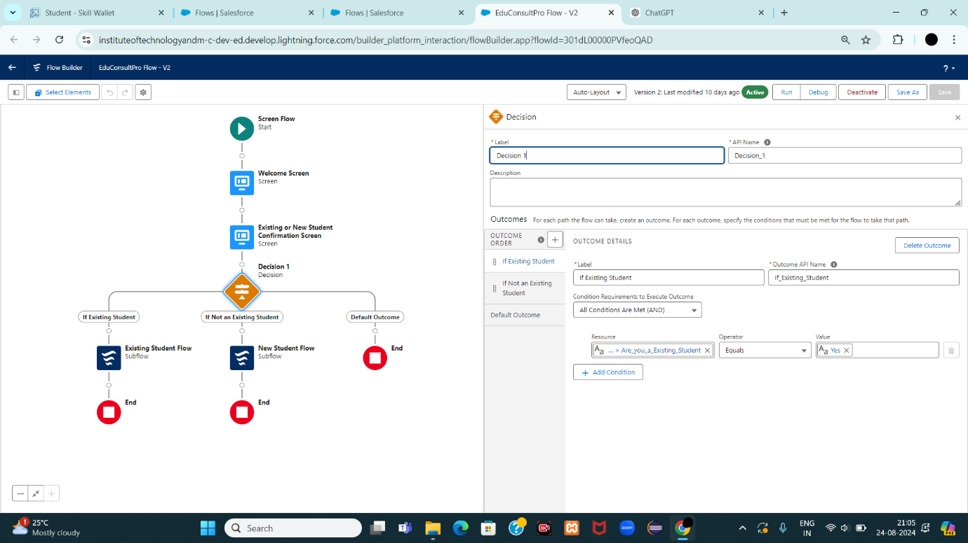

**4. Add SubFlow Elements**

1. **Add SubFlow for Existing Student**:
   * Drag a **SubFlow** element onto the **If Existing Student** path after the **Decision 1** element.
   * Search for and select **EduConsultantPro Existing Student Flow**.
   * Label it as **Existing Student Flow**.
   * 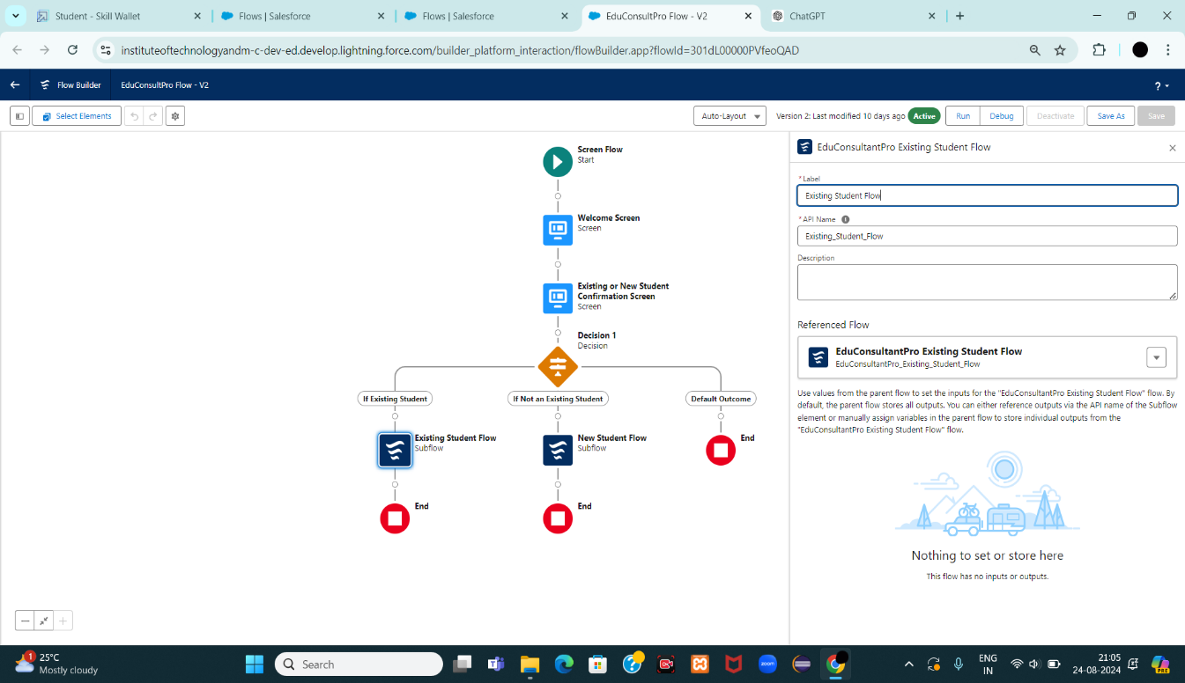
2. **Add SubFlow for New Student**:
   * Drag a **SubFlow** element onto the **If Not an Existing Student** path after the **Decision 1** element.
   * Search for and select **EduConsultantPro Student Flow**.
   * Label it as **New Student Flow**.
   * 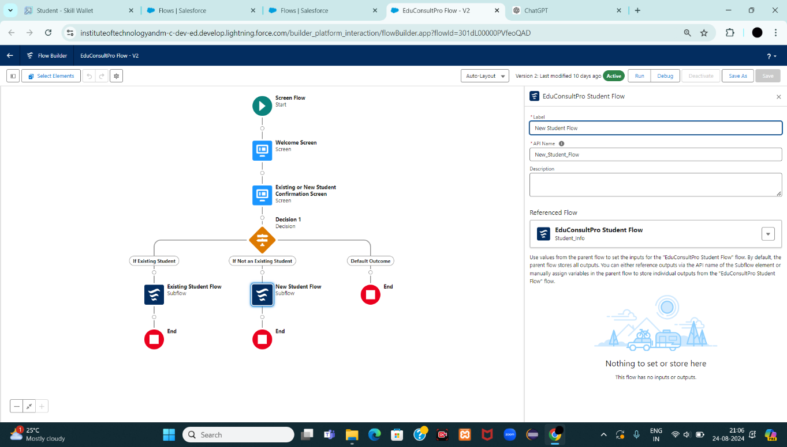

**5. Save and Activate the Flow**

1. **Save the Flow**:
   * Click on **Save**.
   * Label it as **EduConsultantPro Combined Flow**.
2. **Activate the Flow**:
   * Click on **Activate** to make the flow live.

**Create a lightning app page**

1. **Open Lightning App Builder:**
   * From Setup, type "App Builder" in the Quick Find box.
   * Click on **Lightning App Builder**.
2. **Create a New Home Page:**
   * Click on **New**.
   * Select **Home Page**.
   * Click **Next**.
3. **Configure the Home Page:**
   * Enter the **Page Name** as “EduConsultPro Home Page”.
   * Choose the **Standard Home Page** template.
   * Click **Done**.
4. **Add Components to the Page:**
   * In the page layout editor, drag the **Flow** component to the top-right region of the page.
   * In the **Flow** component's configuration panel, search for and select the **“EduConsultantPro Flow”**.
5. **Save the Page:**
   * Click **Save**.
   * 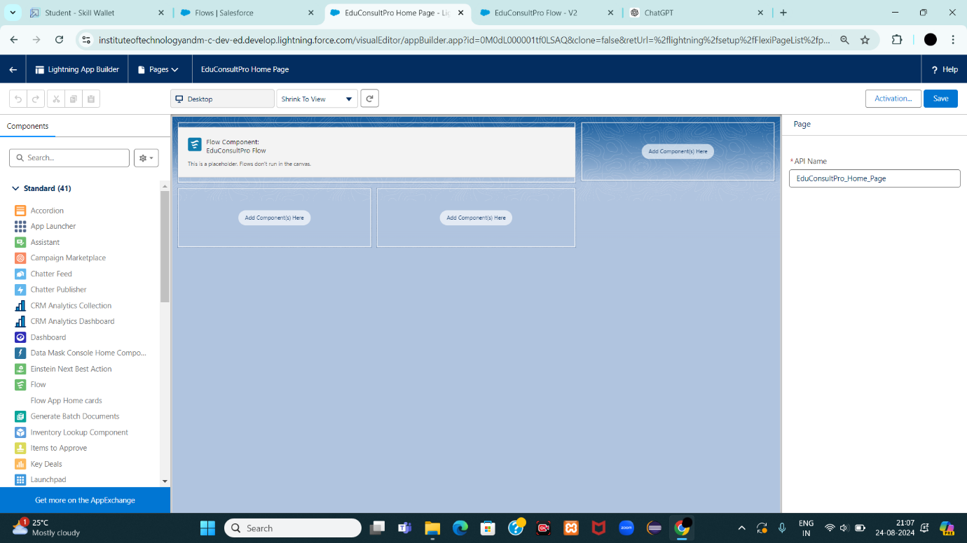
6. **Activate the Page:**
   * To make the page available in your application, click **Activate**.
   * Choose the appropriate options to add it to the app (e.g., Default for specific profiles or as a utility).
7. **Publish the Page:**
   * Click **Publish** to make the page live and accessible in your Salesforce environment.